**Topic: -** Stock Market forecasting using Time-Series Analysis

**Company whose data is being referred to: -** State bank of India

**Technology Stack:-**

**Programming Language: -** Python 3

**Libraries: -** Numpy

Pandas

Matplotlib

Scikit-Learn

**Time-Series: -** is simply a series of data points ordered in time. In a time series, time is often the independent variable and the goal is usually to make a forecast for the future.

The Time-Series generated may have any of the 3 properties:-

1. **Auto-Correlation: -** is the similarity between observations as a function of the time lag between them. For example, in the graph below the first and the 24th value have a high autocorrelation similarly for the 12th and 36th value.

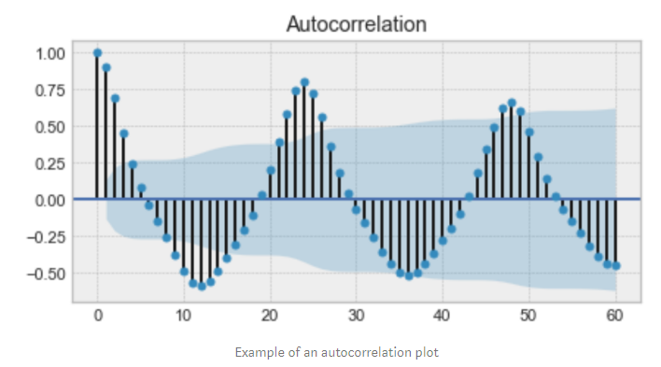

1. **Seasonality: -** Refers to periodic functions, for example electricity consumption is high during the day and low during night, or online sales increase during Christmas before slowing down again. Seasonality can also be derived from an **Auto-Correlation Plot** if it has a sinusoidal shape.

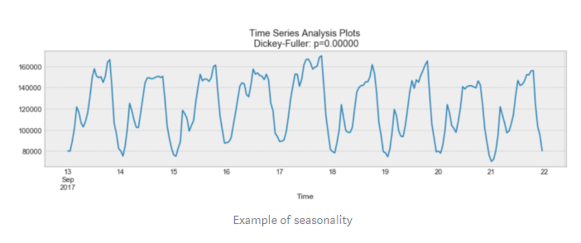

1. **Stationarity: -** is an important characteristic of time-series. A time-series is said to be stationary if its statistical properties do not change over time. In other words, it has constant mean and variance, and co-variance is independent of time.

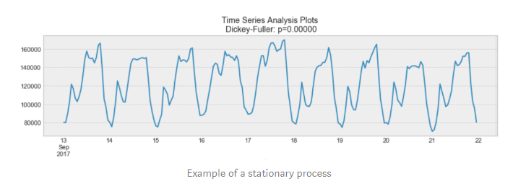

In the above, we see that the process above is stationary. The mean and variance do not vary over time.

Often **Stock Prices** are not a stationary process, since we might see a growing trend, or its volatility might increase over time i.e. variance is ever-changing.

Ideally, we want to have a stationary time-series for modelling. Of course, not all of them are stationary, but we can make different transformations to make them stationary.

**Fundamentals of Trading: -**

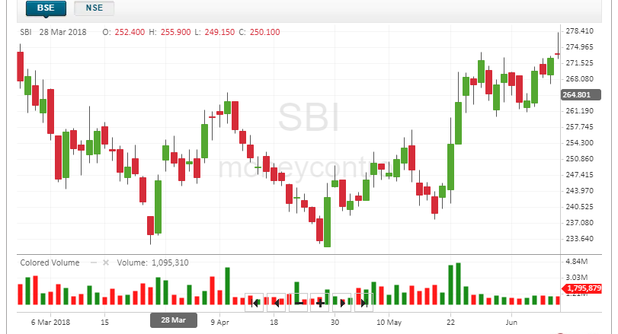

In the above graph,  
 we see a peculiar representation technique being used which is known as a candlestick, a candlestick is a type of price chart used in technical analysis that displays the high, low, open, and closing prices of a security for a specific period.

The Color of the Bar i.e. Red or Green denotes that the stock closed on a Lower price or a Higher Price respectively on that particular day.

From the colors we can also conclude that Red or Black means there are a more number of buyers is more in the market as they will try to drive the price of security down so as to buy it at a low cost, and Green or White means that the numbers of seller of that particular security is more as they will try to drive the price higher so as to earn maximum profit on selling the security.

There is a third state which is known as a consolidated state, in which the number of buyers and sellers for a security are the same in the market. In this case, it is denoted using a simple horizontal line.  
  
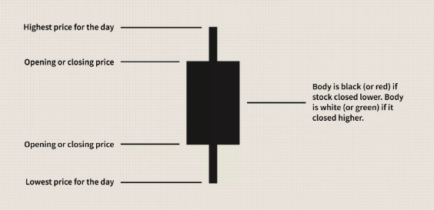

The main factors which bring about a huge change in the variance and mean of the security prices are:-

1. **Buyer and Seller**
2. **IPO: -** stand for Initial Public Offering. When the news media report that a company is "going public," this **means** that company is making an **initial public offering**. This **means** that the company is offering its shares for sale to the public for the first time.
3. **Pandemics**
4. **Merger and Acquisitions: -** Mergers and acquisitions are transactions in which the ownership of companies, other business organizations, or their operating units are transferred or consolidated with other entities.
5. **Import and Export**
6. **Government Issues/Changes to Laws.**